**ST425 PROJECT**

**Title: Risk Analysis on Insurance Company**

**GROUP 1**

**Members:** 13783, 78137,02831,13813

**1. Background**

The study of insurance covers several aspects, from types of insurance, for instance, life insurance or liability insurance to the loss analysis. This report is focused on the risk management and insight into loss of insurance company. The models mentioned as follows are based on the study of balance of the company, where income and liability simply come from premium and claims respectively. The variables taken into consideration in this model are the size of the claims, the size of the premium and the probability of a customer making a claim. The size of the claim ,denoted by X, is drawn from a Pareto Distribution with the density function below

$$f\left(x\right)=\left\{\begin{aligned}0 x≤0 \\ \\ \frac{{αβ}^{α}}{{\left(x+β\right)}^{α+1}} x>0\end{aligned}\right.$$

The premium and probability of a customer making a claim are treated as a constant, unless changes are made to analyze the impact of these on the risk of bankruptcy. The analysis is extended in such a way that the period taken into consideration extends from 1 year to 10 years with float variables. However, the real-life situation is complicated, which implies there exist reservations of our models based on some assumptions. Though not practical enough, this simplified model is still meaningful and researchable.

**2. Basic Calculation and Analysis**

**2.1 Calculating the Cumulative Distribution Function of $X$**

$$f\left(x\right)=\left\{\begin{aligned}0 x≤0 \\ \\ \frac{{αβ}^{α}}{{\left(x+β\right)}^{α+1}} x>0\end{aligned}\right.$$

$$F\left(x\right)=P(X≤x)$$

Since $X$ is a continuous random variable, this is obtained by integrating the density function from 0 to $x$

$$F\left(x\right)=\left\{\begin{aligned}0 x≤0 \\ \\ \int_{0}^{x}{\frac{{αβ}^{α}}{{\left(t+β\right)}^{α+1}}dt x>0}\end{aligned}\right.$$

$$\int_{0}^{x}{\frac{{αβ}^{α}}{{\left(t+β\right)}^{α+1}}dt=-β^{α}{(t+β)}^{-α}\left|{x \atop 0}=1-β^{α}{(x+β)}^{-α}\right.}$$

**2.2 Expectation of $X$**

$$E\left(X\right)=\int_{-∞}^{+∞}{xf(x)dx=\int_{0}^{∞}{x∙\frac{{αβ}^{α}}{{\left(x+β\right)}^{α+1}}dx}}$$

$$=\int_{0}^{∞}{(x+β)∙\frac{{αβ}^{α}}{{\left(x+β\right)}^{α+1}}dx}-\int_{0}^{∞}{\frac{{αβ}^{α+1}}{{\left(x+β\right)}^{α+1}}dx}$$

$$=\int_{0}^{∞}{\frac{{αβ}^{α}}{{\left(x+β\right)}^{α}}dx}+β^{α+1}{(x+β)}^{-α}\left|{∞ \atop 0}\right.$$

$$=\frac{{αβ}^{α}}{1-α}{\left(x+β\right)}^{1-α}\left|{∞ \atop 0}-β=\frac{β}{α-1}\right.$$

**Conditions for the parameters:**

$$α>1,β>0$$

$X$ is a positive random variable, therefore clearly $β>0$ leading to a positive mean size of claims. Also $α>1$ for the same reason, ensuring that the basic integration step can be applied. Clearly, $α≠1$ to ensure that the mean size of claim is well defined.

**2.3 Median of $X$**

Let $F\left(x\right)=1-β^{α}{\left(x+β\right)}^{-α}=\frac{1}{2}$

Solving for $x$*,*

$$Median of X=β(2^{1/α}-1)$$

**2.4 Variance of $X$**

By definition,

$$Var\left(X\right)=E\left(X^{2}\right)-{E(X)}^{2}$$

$$=\int_{0}^{∞}{x^{2}∙\frac{{αβ}^{α}}{{\left(x+β\right)}^{α+1}}dx}-{(\frac{β}{α-1})}^{2}$$

$$=\int_{0}^{∞}{{\left(x+β\right)}^{2}∙\frac{{αβ}^{α}}{{\left(x+β\right)}^{α+1}}dx}-2β\int_{0}^{∞}{x∙\frac{{αβ}^{α}}{{\left(x+β\right)}^{α+1}}dx}$$

$$-β^{2}\int_{0}^{∞}{\frac{{αβ}^{α}}{{\left(x+β\right)}^{α+1}}dx}-{(\frac{β}{α-1})}^{2}$$

$$=\int_{0}^{∞}{\frac{{αβ}^{α}}{{\left(x+β\right)}^{α-1}}dx}-\frac{2β^{2}}{α-1}-β^{2}-{(\frac{β}{α-1})}^{2}$$

$$=\frac{{αβ}^{α}}{2-α}{(x+β)}^{2-α}\left|{∞ \atop 0}\right.-\frac{2β^{2}}{α-1}-β^{2}-{(\frac{β}{α-1})}^{2}$$

$$=\frac{{αβ}^{2}}{2-α}-\frac{2β^{2}}{α-1}-β^{2}-{\left(\frac{β}{α-1}\right)}^{2}=\frac{β^{2}α}{{\left(α-1\right)}^{2}\left(α-2\right)}$$

**Conditions for the parameters:**

$$α>2,β>0$$

Variance is strictly positive . Hence $α>2 and β>0$. Clearly $α≠2$, again ensuring that the variance is well defined.

**2.5 The Inversion Method**

1. Generate ui (0,1)
2. Set ui=F(xi) and make xi the subject

$$F\left(x\right)=u$$

$$1-β^{α}{(x+β)}^{-α}=u$$

$$x=β∙{(1-u)}^{-1/α}-β$$

This can be done since F(x) is continuous and strictly increasing based on the restrictions imposed on the parameters. Based on the above method, we can simulate 1000 values drawn from the pareto distribution as shown in Figure 2-1. The histogram with the true density function superimposed is as below:

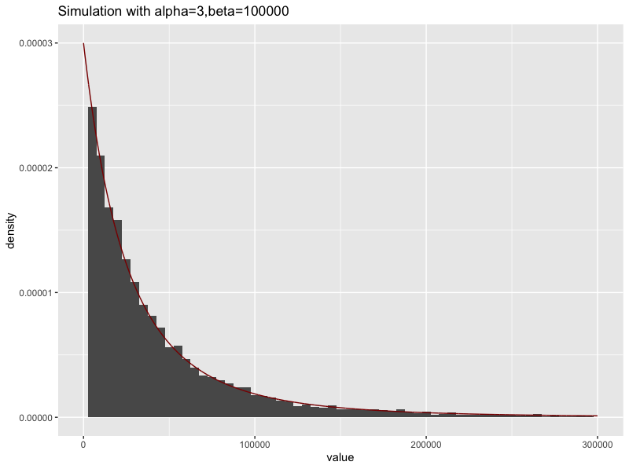

Figure 2-1:Simulation of pareto distribution

**2.6 Reasons for Use of Pareto Distribution to Describe Size of Claims**

* The Pareto Distribution is positively skewed and has a heavy tail on the right.

For this reason, we use Pareto for insurance applications to model extreme

loss,especially for more risky types of insurance.

* It is a mixture of the exponential distribution with gamma mixing weights.
* In financial applications , the study of heavy tailed distributions provides information about the potential for financial failure(bankruptcy)

**3. Model for Assets at the end of the year.**

**3.1 Build the Model**

Based on the given information, we built up the asset model as follows:

$$Z=a+cn-S$$

$Z$*:* the assets of the company at the end of the year(in £)

$a=£250000$ represents the current assets of the company.

$c=£6000$ represents the annual premium.

$n=1000$ represents the number of the customers.

Total claim:

$$S=\sum_{i=1}^{N}{X_{i}}$$

Size of claim of each customer, $X_{i}\sim$ Pareto distribution i.i.d.

$N=\sum_{j=1}^{1000}{Y_{j}}$: the number of clients making a claim this year.

For $Y_{j} i.i.d$.:

$\left\{\begin{aligned}P\left(Y_{j}=1\right)=0.1,if a claim is made \\ \\ P\left(Y_{j}=0\right)=0.9, otherwise\end{aligned}\right.$

We should calculate the bankruptcy probability:

$$P(Z<0)$$

As it can be seen from the simulation graph 3-1, the distribution of assets are negatively skewed which is clearly compatible with the positive skewness of the Pareto distribution. Assets and Total size of claims are negatively related. S, denoted by the total size of claims

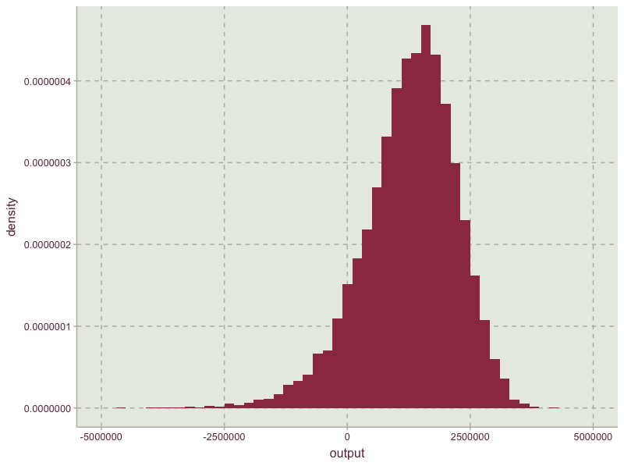

Figure 3-1: Simulation of assets at year end

here is a combination of the Pareto distribution and the Bernoulli distribution.

From the simulation we worked out the following:

The Expected Assets at yearend: **£1249603.2379**

Probability that the company is bankrupt: **0.0977**

**3.2 Impact of Premium and Probability of Making a Claim**

**The effect of premium on probability of bankruptcy**

Throughout this analysis we only change the premium, whilst controlling for the rest of the variables in the question. We analyzed the effects for premium levels ranging from £5500 to £8000 increasing it by £500 each time.

The outcome of the effect on probability of bankruptcy is as follows(Figure 3-2 & Table 3-1):

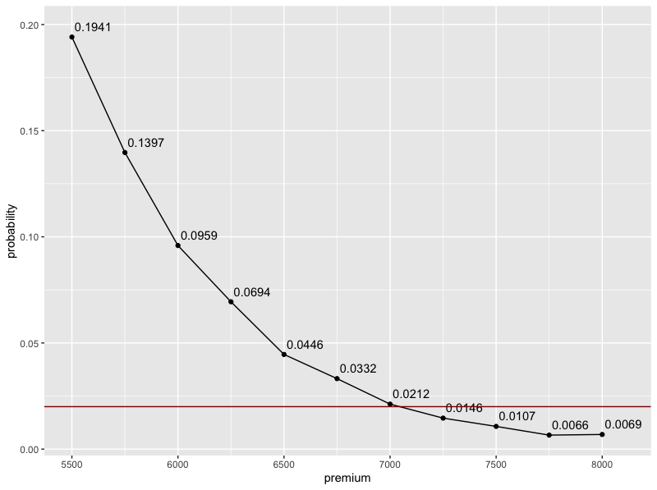

Figure 3-2: Bankruptcy-Premium tendency

|  |  |  |
| --- | --- | --- |
| premium | balance | probability |
| 5500 | 741136.600292234 | 0.1941 |
| 5750 | 1003137.73320141 | 0.1397 |
| 6000 | 1255157.61448557 | 0.0959 |
| 6250 | 1498083.97452799 | 0.0694 |
| 6500 | 1759673.68190743 | 0.0446 |
| 6750 | 2002743.62758197 | 0.0332 |
| 7000 | 2251394.98058984 | 0.0212 |
| 7250 | 2490678.65689442 | 0.0146 |
| 7500 | 2740845.10927589 | 0.0107 |
| 7750 | 2994727.17767397 | 0.0066 |
| 8000 | 3255043.86669691 | 0.0069 |

Table 3-1: Premium’s effect on bankruptcy

Clearly, the probability of bankruptcy declines with an increase of premium levels.

However to ensure that the probability of bankruptcy is no more than 2% we need to charge for a premium of at least £7250.

**The effect of probability of a customer making a claim on the probability of bankruptcy**

Here, we change the probability of a customer making a claim ,controlling for premium and other variables in the question.

The analysis has been carried out for probability ranging from 0.05 to 0.15 increasing it by a 0.005 each time. The outcome is as follows(Figure 3-3 & Table 3-2):

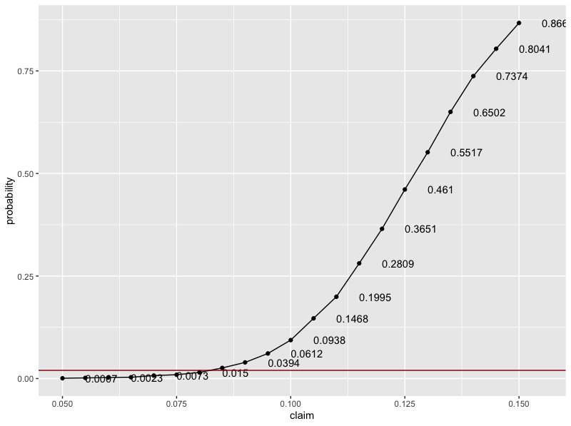

Figure 3-3: Bankruptcy-Probability of making a claim

|  |  |  |
| --- | --- | --- |
| claim | balance | probability |
| 0.05 | 3759849.64385291 | 0.0007 |
| 0.055 | 3497623.5856642 | 0.0016 |
| 0.06 | 3260109.47219399 | 0.0023 |
| 0.065 | 3009525.64706615 | 0.0032 |
| 0.07 | 2746500.63048726 | 0.0073 |
| 0.075 | 2490617.99967582 | 0.0094 |
| 0.08 | 2243506.9708276 | 0.015 |
| 0.085 | 1998117.96791791 | 0.0259 |
| 0.09 | 1740876.91939939 | 0.0394 |
| 0.095 | 1499039.79317023 | 0.0612 |
| 0.1 | 1251768.85848942 | 0.0938 |
| 0.105 | 993418.842385709 | 0.1468 |
| 0.11 | 754042.482872268 | 0.1995 |
| 0.115 | 502591.533068519 | 0.2809 |
| 0.12 | 252371.527546531 | 0.3651 |
| 0.125 | -1004.49002706269 | 0.461 |
| 0.13 | -242388.017059418 | 0.5517 |
| 0.135 | -497185.30799758 | 0.6502 |
| 0.14 | -746170.992160119 | 0.7374 |
| 0.145 | -991378.617794178 | 0.8041 |
| 0.15 | -1247132.70224009  Table 3-2: Probability’s effect on bankruptcy | 0.8669 |

We observe a positive trend between the two variables as expected. The higher the chance of a customer making a claim, the higher the claims that the company has to pay for, thus increasing the probability of bankruptcy since premium is fixed.

To ensure that the probability of bankruptcy is no more than 2% we need to control the probability of a customer making a claim to no more than 8%.

**3.3 Find the portfolio**

Combining what we have done before, given a probability, we calculate the minimal premium needed to avoid bankruptcy. The outcome is shown as Table 3-3.

For probability (of making a claim) more than 0.11, the premium will be beyond the upper limit (which is 8000) of given premium intervals. We consider those as abnormal situationsthat will not be accepted. (it means that even when the premium approaches 8000, you can’t reduce the probability of bankruptcy to 0.02).

|  |  |
| --- | --- |
| Probability | premium |
| 0.05 | 5500 |
| 0.055 | 5500 |
| 0.06 | 5500 |
| 0.065 | 5500 |
| 0.07 | 5500 |
| 0.075 | 5750 |
| 0.08 | 5750 |
| 0.085 | 6250 |
| 0.09 | 6500 |
| 0.095 | 7250 |
| 0.1 | 7250 |
| 0.105 | 7750 |
| 0.11 | 7750  Table 3-3: Portfolio |

1. **Extending and Improvement**

Our previous modelling was based on fixed premiums and probability of each person making a claim. Obviously it can’t be true in reality. Considering the limitations, we have extended our model as explained below.

**4.1 Assumptions**

* Consider 10 years’ time period
* The number of customers is not fixed every year and the premium is not necessarily paid at the start of a year. The total number of paying for annual premium has a Poisson distribution.
* The probability of customers making a claim is not identical for everyone. Assume the number of times making a claim also has a Poisson distribution.

**4.2 Building the Model**

The equation of new model:

$$Z(t)=a+cM(t)-S(t)$$

$Z(t)$: the assets of the company at the end of the year $t$.

$a=250000$ represents the current assets of the company.

$c=6000$ represents the annual premium.

$M(t)$: the number of times of paying for premium until year $t$. It has a Poisson distribution of parameter $λ_{1}t$. The pdf of $M(t)$ is:

$$P\left(M\left(t\right)=k\right)=\frac{{\left(λ_{1}t\right)}^{k}}{k!}e^{-λ_{1}t}, k=0,1,2…$$

Total claim till the end of year $t$:

$$S(t)=\sum_{i=1}^{N(t)}{X_{i}}$$

$X_{i}\sim$ Pareto distribution i.i.d.

$N(t)$: the number of claims made until year $t$. It has a Poisson distribution of parameter $λ_{2}t$. The pdf of $N(t)$ is:

$$P\left(N\left(t\right)=k\right)=\frac{{\left(λ_{2}t\right)}^{k}}{k!}e^{-λ_{2}t}, k=0,1,2…$$

Assume $λ_{1}=1000$, $λ_{2}=100$, we can simulate the assets of the company in the end of year t and compare the probability of bankruptcy at the end of each year.

The function to simulate the balance of the company is shown as follows,

1. PoisSim<-function(n,t,premium,lambda1,lambda2){
2. balance<-matrix(0,n,t)
3. **for** (k **in** 1:n){
4. **for** (i **in** 1:t) {
5. num<-rpois(1,lambda2)
6. claim<-sum(rpareto(num,alpha,beta))
7. **if**(i==1){
8. balance[k,i]<-250000+premium*rpois(1,lambda1)-claim
9. }
10. **else**{
11. balance[k,i]<-balance[k,i-1]+premium*rpois(1,lambda1)-claim
12. }
13. }
14. }
15. balance
16. }
17. **Report**

Based on our analysis, we present the following findings regarding factors that contribute to the risk of bankruptcy. Firstly, we have provided the assumptions of the model, followed by the factors the company can control and reservations of the model .Lastly, we have provided a brief suggestion on how the analysis can be extended and our findings with this extension have been explained.

* **Assumptions**

First and foremost, we should set few assumptions especially for the variables selected in our model. Besides, the basic assumptions provided, there should be some additional assumptions to ensure that the model working well.

The first and the second assumption is that **for each year, one customer can only make one claim and the probability of customers making a claim is fixed and equal for each customer**. **Claims are made independently of each other and of customers.** That is, there is no probable situation that the decision of one customer could be influenced by another .

For simplification purposes, we also assume that **the value of the premium is fixed irrespective of the size of the claim.** Practically speaking, we assume that every customer of the insurance company will buy identical products with equal premium. Besides, we don’t consider the situation that some of the customers drop out at any circumstance. For instance, some customers might quit due to the increasing of premium when a financial crisis happens.

In real insurance contract, when a customer buys insurance to protect themselves against unforeseen risks, they should agree to pay for the first part of the future loss. This part paid by customers is the so-called deductible, which has also been dropped in our model provided. We have assumed instead that **the company will pay the entire loss for customers**, which potentially increases the probability of bankruptcy.

In corporate finance, the calculation of total asset needs specific data from financial statements. To simplify the calculating procedures, we assume that the company will **retain all premiums charged with itself and not engage in any transactions like borrowing to cover the losses incurred.**

* **Factors that the company can control**

Based on the assumptions and outcomes of the simulation, there are factors that can be controlled by the company in order to reduce the risk of bankruptcy.

The first factor that the company should pay more attention to is the **premium**. In this case, to ensure that the risk of bankruptcy is less than 2%, the minimum premium that the company should charge is £7250. It is best if the company can stand firm with this pricing which will indeed improve the company’s reputation.

The second factor is the **probability of customers making a claim**. The company can forecast the probability of a customer making a claim before accepting customers and accept those who are at most 8% likely to make a claim. This in turn can ensure the risk of bankruptcy to be less than 2% based on the calculation perfomed.

Besides, the company can also find the relationship between number of claims per year and the risk of bankruptcy and limit to the maximum number of claims with minimal risk.

Apart from the technical advices, there are also non-technical factors which the company can control. The company should not wait till the net balance has reached to zero to calculate the risk of bankruptcy. That is, the company should always keep updated with the evaluations. On the other hand, the company can mitigate its risk by exploring the option of **reinsurance**, which can spread the risk to other financial institutions. The company should also conduct frequent **seminars**, providing advice to minimize avoidable risks and network with the customers.

* **Reservations**

However, the results based on our predictions are not realistic. We should make some adjustments when we are considering specific scenarios. For example, we assumed the probability of each customer making a claim in a year to be 0.1, but that can be vary with certain factors such as the age, gender, income of the customers. Also, claims made by customers are not always independent of each other. We believe there are some clients of the company who are friends or relatives and it is impossible to avoid them discussing their opinions or sharing their feedback about products. They might arrive at similar conclusions of whether to continue to invest in the company, so public praise is quite important for our company. This should be given priority. We also hope you can provide me with more previous data, especially the amount of claims made each time.which can help us simulate the distribution and make a better prediction because in the model assumed ,the parameters were based on general circumstances for this kind of insurance, while it varies among different companies and client groups.

* **Extending**

Based on these disadvantages, a more suitable model was formulated .The time period has been extended to ten years because we should have a long-term consideration and not just focus on the end of this year. The fluctuation of number of customers every year and the scenario that a customer may make more than one claim per year have also been considered. Also, the premiums need not necessarily be paid at the beginning of the year by each customer. In the analysis, we have concluded that the risk of bankruptcy increases with time. But if we can overcome the difficulties and exclude less probable events (claims exceeding average levels), we can expect the assets of our company to increasing continuously. Based on the parameters used, the risk of bankruptcy in ten years is 0.1456 which is a little high for us. A suggestion is to increase the premium for each year to be £7,500 which in turn did reduce the risk of bankruptcy to 0.02 which was concluded by computation. This helps us to achieve maximal net balance with minimal risk of bankruptcy.

The plot below shows the distribution of the asset balance of the company year of the new model at the end of each year compared to that of the initial model at the end of the first year. As we can see in the plot, the initial model and the first year of extending model almost overlaps. The green area shows the balance distribution at the end of 10th year. This has the highest expected asset balance which is our goal. The mean and variance increases annually.

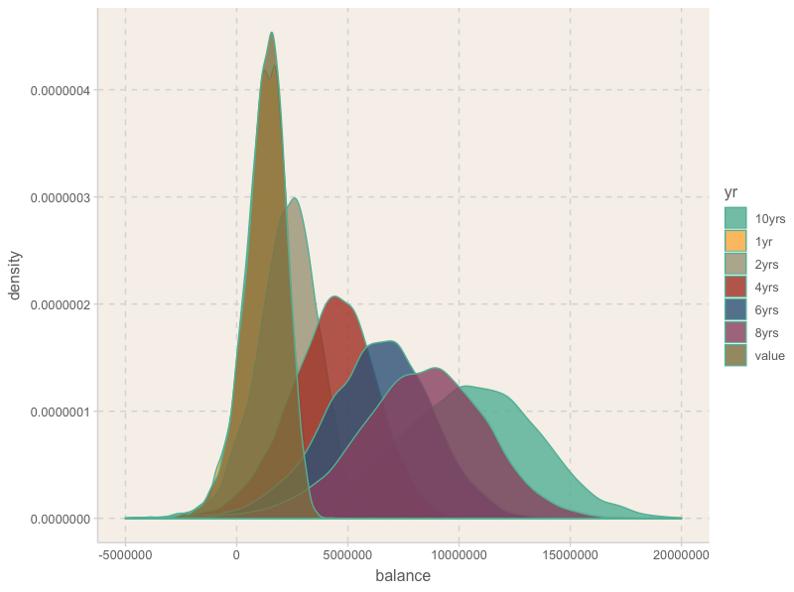

**6. Appendix**

1. ######1
2. rm(list=ls())
3. library(ggplot2)
4. library(dplyr)
5. library(actuar)
6. library(ggthemr)
7. library(tidyr)
8. set.seed(123)
9. alpha<-3
10. beta<-100000
11. n<-10000
12. u<-runif(n)
13. x<-beta*(1/((1-u)^(1/alpha))-1)  #inversion method to simulate pareto
14. options(scipen = 200)
15. z=seq(0,299970,30)
16. data.frame(value=x)%>%  #get the simulation plot
17. ggplot(.,aes(x=value))+geom_histogram(aes(y=..density..),binwidth = 5000)+
18. geom_line(aes(z,dpareto(z,alpha,beta)),color="darkred")+  #true line
19. xlim(0,300000)+ggtitle("Simulation with alpha=3,beta=100000")
20. ######2  simulation function for asset
21. AssetSim<-function(n,premium,prob){
22. balance<-0
23. **for** (k **in** 1:n) {
24. claim<-rbinom(1000,1,prob)
25. cost<-0
26. **for** (i **in** 1:1000) {
27. **if**(claim[i]==1){cost<-cost+rpareto(1,alpha,beta)}
28. }
29. balance[k]<-250000+1000*premium-cost
30. }
31. balance
32. }
33. output<-AssetSim(10000,6000,0.1)
34. summary(output)
35. ggthemr("grape")
36. ggplot(as.data.frame(output),aes(x=output))+geom_histogram(aes(y=..density..),binwidth = 200000)+xlim(-5000000,5000000)  #simulation visualization
37. cat(paste("The expected asset: ",mean(output)))  #mean balance
38. cat(paste("The probability of bankrupt: ",mean(output<0)))  #prob bankruptcy
39. #######3
40. premium<-seq(5500,8000,250)
41. prob<-seq(0.05,0.15,0.005)
42. dt1<-data.frame(premium=premium, balance=0,probability=0)
43. dt2<-data.frame(claim=prob, balance=0,probability=0)
44. **for** (i **in** 1:length(premium)){
45. output<-AssetSim(10000,premium[i],0.1)
46. dt1$balance[i]<-mean(output)
47. dt1$probability[i]<-mean(output<0)
48. }  #loop to test premium effect
49. p<-ggplot(dt1,aes(premium,probability))+geom_text(aes(label=probability),check_overlap=TRUE,nudge_y=0.005,nudge_x=100)+geom_point()+geom_line()
50. p+geom_hline(aes(yintercept = 0.02),colour="dark red")
51. cat("Minimal premium level:",min(dt1$premium[dt1$probability<0.02]),"\n")
52. #get the minimal premium to control the bankruptcy prob under 2%
53. **for** (i **in** 1:length(prob)){
54. output<-AssetSim(10000,6000,prob[i])
55. dt2$balance[i]<-mean(output)
56. dt2$probability[i]<-mean(output<0)
57. }  #loop to test probability effect
58. p<-ggplot(dt2,aes(claim,probability))+geom_point()+geom_text(aes(label=probability),check_overlap=TRUE,hjust=0,nudge_x=0.005)+geom_line()
59. p+geom_hline(aes(yintercept = 0.02),colour="dark red")
60. cat("maximal probability of making a claim:",max(dt2$claim[dt2$probability<0.02],"\n"))
61. #get the maximal probability to control the bankruptcy prob under 2%
62. #### find optimal portfolio
63. prob<-as_tibble(prob) %>%mutate(premium=0)
64. **for** (i **in** 1:length(prob$value)){
65. j=1
66. **while** (j <=length(premium)) {
67. prob0<-mean(AssetSim(1000,premium[j],prob$value[i])<0)
68. **if**(prob0<0.02){
69. prob$premium[i]<-premium[j]
70. **break**}
71. j=j+1
72. }
73. }
75. ###extending model
76. ##control lambda1=10000, lambda2=1000
77. PoisSim<-function(n,t,premium,lambda1,lambda2){
78. balance<-matrix(0,n,t)
79. **for** (k **in** 1:n){
80. **for** (i **in** 1:t) {
81. num<-rpois(1,lambda2)
82. claim<-sum(rpareto(num,alpha,beta))
83. **if**(i==1){
84. balance[k,i]<-250000+premium*rpois(1,lambda1)-claim
85. }
86. **else**{
87. balance[k,i]<-balance[k,i-1]+premium*rpois(1,lambda1)-claim
88. }
89. }
90. }
91. balance
92. }
93. out<-PoisSim(10000,10,6000,1000,100)
94. **is**.neg<-apply(out,1,function(row) any(row<0))  #calculate bankruptcy
95. length(which(**is**.neg))/10000  #bankruptcy prob
96. Summary_table<-as_tibble(output) %>% mutate("1yr"=0,"2yrs"=0,"4yrs"=0,"6yrs"=0,"8yrs"=0,"10yrs"=0)
97. Summary_table[2]<-out[,1]
98. Summary_table[3]<-out[,2]
99. Summary_table[4]<-out[,4]
100. Summary_table[5]<-out[,6]
101. Summary_table[6]<-out[,8]
102. Summary_table[7]<-out[,10]
103. new_table<-gather(data=Summary_table,key="yr",value="balance",value,"1yr","2yrs","4yrs","6yrs","8yrs","10yrs")
104. ggthemr("light")
105. ggplot(new_table,aes(x=balance,fill=yr))+geom_density(alpha=.8)+theme(legend.position = "right")+xlim(-5000000,20000000)
106. #build functions to find out the bankruptcy probability
107. ProbOfBank<-function(n,t,premium,lambda1,lambda2,threshold){
108. outcome<-PoisSim(n,t,premium,lambda1,lambda2)
109. **is**.neg<-apply(outcome,1,function(row) any(row<threshold))
110. length(which(**is**.neg))/n
111. }
112. dt3<-data.frame(premium=seq(5500,8000,250),prob=0)
113. **for** (i **in** 1:length(premium)){
114. dt3$prob[i]<-ProbOfBank(1000,10,premium[i],1000,100,0)
115. }
116. cat("Minimal premium level:",min(dt3$premium[dt3$prob<0.02]),"\n")
117. write.csv(prob[1:13],"result.xlsx",applend=TRUE)